**NAME:** Shivam Tiwari

**ROLL NO:** 5117060

**EXPERIMENT 01**

**Aim:** To study about the different deployment models of Cloud Computing, the concept of virtualization and various advantages and disadvantages of Cloud Computing

**Theory:**

**Cloud Computing** is a general term used to describe a new class of network-based computing that takes place over the Internet, basically a step on from Utility Computing a collection/group of integrated and networked hardware, software and Internet infrastructure (called a platform). Using the Internet for communication and transport provides hardware, software and networking services to clients. These platforms hide the complexity and details of the underlying infrastructure from users and applications by providing a very simple graphical interface or API.

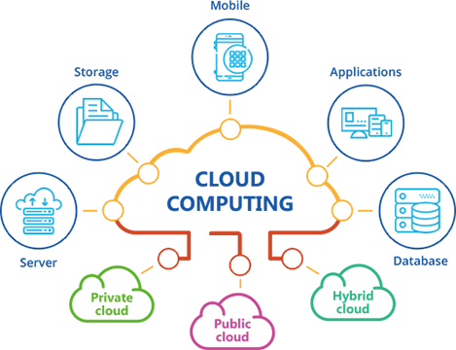

**There are 3 main types of Cloud models**

* Public Cloud
* Private Cloud
* Hybrid Cloud

**Services Provided by Cloud**

Cloud providers will typically offer various computing services.

**Infrastructure as a Service (IaaS)**

This is a service model that builds the foundation for a business's cloud technology. Infrastructure as a Service is considered to be the most flexible and all-inclusive cloud application because it provides a multitude of resources. This includes on-demand networking, data storage, and processing power. Iaas also does not require hardware investments since these resources are provided by the platform. People that want a cost-efficient and scalable cloud solution will often turn to IaaS.

**Platform as a Service (PaaS)**

Platform as Service is considered to be the advanced version of Infrastructure as a Service. PaaS provides an IT structure, computing platform, and solution stack. It also helps non-expert users with creating custom apps on the web without any concern for data storage and management. Additionally, PaaS offers hosting solutions, network access, and server software.

**Software as a Service (SaaS)**

The computing service, SaaS, consolidates the different services that IaaS and PaaS provide. Software as a Service caters to diverse business functions, such as business analytics, automation, and customer management. SaaS also offers browser-based software apps that are user-friendly, reducing the need for IT specialists, laborious set-up, and maintenance. This is the most common cloud computing service, in which people often use SaaS apps, like Gmail and Slack.

**Function as a Service (FaaS)**

Function as a Service is a relatively new form of cloud computing. The platform allows software developers to create apps without the need for a server. This helps increase efficiency and gives specialists the ability to focus on developing applications. Some examples of FaaS solutions include Google Cloud Function and Microsoft Azure Functions.

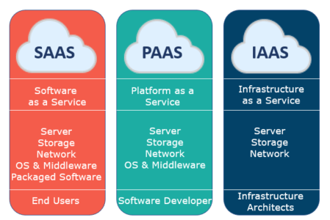

**Virtualization:**

The **Virtualization of Cloud Computing** is to make use of a virtual network of server operating systems and storage systems. This will help to minimize the load on the machine by allowing multiple users to run by their own machines while sharing a single physical machine of a resource or an application. By virtualization, Cloud solutions turn conventional computing resources into far more costly hardware which is not very powerful; the workload being handled by Cloud solutions is often categorized as "Very big and very important."

**Virtualization** also refers to the process of building and running a virtual machine of a computer device in a separate layer that is isolated from the specific hardware being used to run it. The concept behind emulation is to virtualize or pretend to substitute the actual hardware to simplify the task at hand because running software in place of actual hardware has several advantages in software design. Specifically, people are mostly running Microsoft's or Apple's operating system in a virtual machine such as VirtualBox, VMWare, or QEMU that runs on top of the host OS such as Windows or Mac OS.

**Virtualization** is a technology that allows us to build multiple simulation environments from a single, physical hardware device. Look at how my thesis is super-efficient. What we call "virtualization" is a software program known as a hypervisor that connects directly to all hardware and allows us to split 1 device into 2 distinct, independent, and protected worlds known as "virtual machines" (VMs). Thus, these VMs depend on the host operating system's ability to isolate applications and services and the operating system's ability to isolate resources.

**Virtualization** has a great range of uses. Other than being able to run a different operating system on our computer (which is generally called hardware virtualization), it often enables users to assign hardware resources into other functions that optimize our hardware's efficiency. Below are some examples of how cloud computing is being used in a virtual environment.

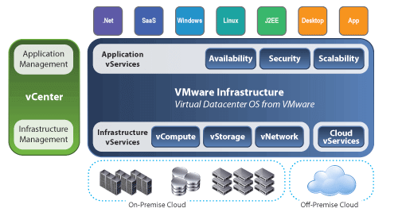

**In the cloud computing environment, how does virtualization work?**

**Virtualization in Cloud Computing** is a mechanism in which the user of the cloud shares the data present in the cloud which can be application software etc. This service offers a virtual world in the cloud, which can be either software or hardware or some other mind-bending stuff. In the virtual server, the cloud provider has the burden of maintaining some of the software and hardware needed by the client and server, while the client and server demands of the cloud provider to maintain some of the software and hardware required by it. That is achieved because the implementation of a new version of an application is very expensive if it must be delivered to the consumers for them to use it.

**Advantages of Cloud Computing**

**Cost Savings**

Cost saving is one of the biggest Cloud Computing benefits. It helps you to save substantial capital cost as it does not need any physical hardware investments. Also, you do not need trained personnel to maintain the hardware. The buying and managing of equipment is done by the cloud service provider.

**Strategic edge**

Cloud computing offers a competitive edge over your competitors. It is one of the best advantages of Cloud services that helps you to access the latest applications any time without spending your time and money on installations.

**High Speed**

Cloud computing allows you to deploy your service quickly in fewer clicks. This faster deployment allows you to get the resources required for your system within fewer minutes.

**Back-up and restore data**

Once the data is stored in a Cloud, it is easier to get the back-up and recovery of that, which is otherwise very time taking process on-premise.

**Automatic Software Integration**

In the cloud, software integration is something that occurs automatically. Therefore, you don't need to take additional efforts to customize and integrate your applications as per your preferences.

**Reliability**

Reliability is one of the biggest benefits of Cloud hosting. You can always get instantly updated about the changes.

**Mobility**

Employees who are working on the premises or at the remote locations can easily access all the could services. All they need is an Internet connectivity.

**Unlimited storage capacity**

The cloud offers almost limitless storage capacity. At any time you can quickly expand your storage capacity with very nominal monthly fees.

**Collaboration**

The cloud computing platform helps employees who are located in different geographies to collaborate in a highly convenient and secure manner.

**Quick Deployment**

Last but not least, cloud computing gives you the advantage of rapid deployment. So, when you decide to use the cloud, your entire system can be fully functional in very few minutes. Although, the amount of time taken depends on what kind of technologies are used in your business.

Other Important Benefits of Cloud Computing

Apart from the above, some other Cloud Computing advantages are:

* On-Demand Self-service
* Multi-tenancy
* Offers Resilient Computing
* Fast and effective virtualization
* Provide you low-cost software
* Offers advanced online security
* Location and Device Independence
* Always available, and scales automatically to adjust to the increase in demand
* Allows pay-per-use
* Web-based control & interfaces
* API Access available.

**Disadvantages of Cloud Computing**

**Performance Can Vary**

When you are working in a cloud environment, your application is running on the server which simultaneously provides resources to other businesses. Any greedy behavior or DDOS attack on your tenant could affect the performance of your shared resource.

**Technical Issues**

Cloud technology is always prone to an outage and other technical issues. Even, the best cloud service provider companies may face this type of trouble despite maintaining high standards of maintenance.

**Security Threat in the Cloud**

Another drawback while working with cloud computing services is security risk. Before adopting cloud technology, you should be well aware of the fact that you will be sharing all your company's sensitive information to a third-party cloud computing service provider. Hackers might access this information.

**Downtime**

Downtime should also be considered while working with cloud computing. That's because your cloud provider may face power loss, low internet connectivity, service maintenance, etc.

**Internet Connectivity**

Good Internet connectivity is a must in cloud computing. You can't access cloud without an internet connection. Moreover, you don't have any other way to gather data from the cloud.

**Lower Bandwidth**

Many cloud storage service providers limit bandwidth usage of their users. So, in case if your organization surpasses the given allowance, the additional charges could be significantly costly

**Lack of Support**

Cloud Computing companies fail to provide proper support to the customers. Moreover, they want their user to depend on FAQs or online help, which can be a tedious job for non-technical persons.

**Conclusion:**

Thus, we have successfully studied about cloud computing, it’s various models, virtualization in Cloud Computing with it’s advantages and disadvantages.